LittleBytes

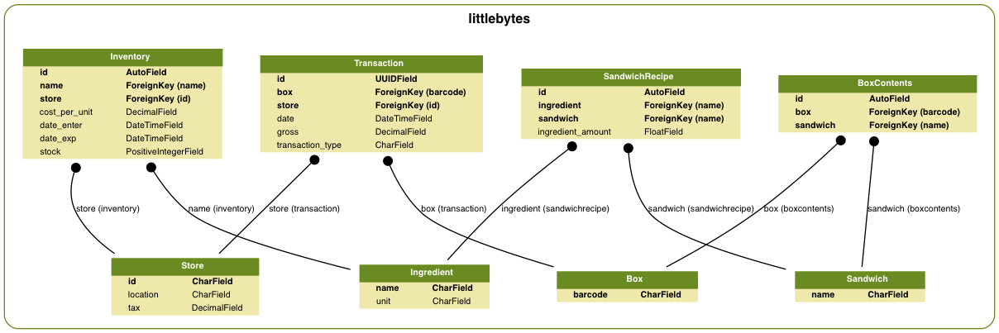

Project: LittleBytes UML

UML Overview: LittleBytes was designed to accommodate multiple stores. It was important to our goal that records, and reports be as flexible as the ever changing market. The idea was to make inventory unique to each store so that the owner, or managers could see what was going on in any of the individual stores. The design was made with the user in mind, we wanted to create a platform that would help users see what the store offered, as well as track transaction throughout the day. This benefits not only the owner, but any employee that may be having trouble keeping track of the day to day activities.

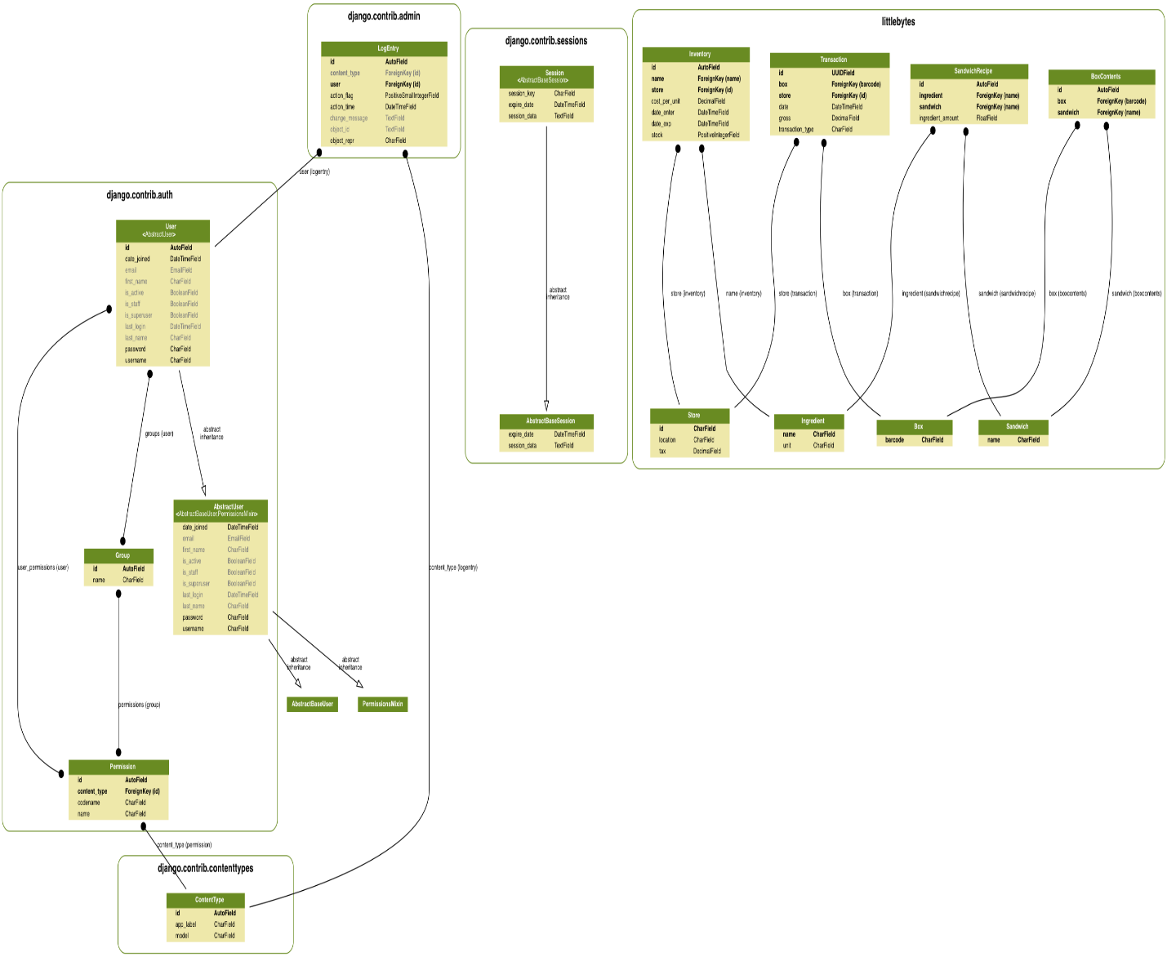

Project: Django UML

UML Overview: Django is what our team decided to use to provide a simple interface that could be implemented in a short amount of time. Django offered a clean an easy to learn interface which is beneficial when trying to implement a new system. The idea was to allow users to create accounts that would grant unique privileges to users depending on their role in the business. Once logged in any information your account has access to can be found, and cleanly displayed.